Team 11
 MEASUREMENT PLAN For VIKING PRJECT
SOFTWARE MEASUREMENT AND ANALYSIS

Create by: Team 11
5/26/2012

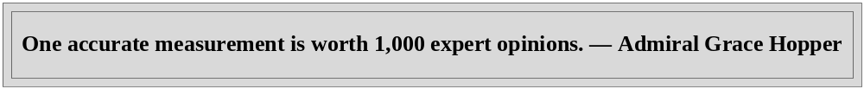
Summary
A good measurement plan contains these elements:
Goal – How would you define success or impact for your program?
Examples:
- “Congregation members will improve their physical health.”
- “Older adults will be less isolated and better connected to a supportive community.”

Outcomes – what changes in behavior or conditions do you expect from your program? Are they achievable in the short-term or intermediate-term?
Measures or Metrics – What types of measures will demonstrate that the desired outcome has been reached?
Method – What tools will you use to collect information? How will you collect information and how often?
Benchmarks – What are the targets that other organizations use to assess the success of their outcomes?
Table of contents
1. Introduction 3
2. Purpose 3
3. Scope 3
4. Establishing a Software Measurement Process 3
4.1. Developing a Measurement Process 5
4.2. Planning the Process 6
4.3. Implementing the Process 6
4.4. Evolving the Process 7
5. 12 Steps to Useful Software Metrics 7
5.1. Step 1 – Identify Metrics Customers 7
5.2. Step 2 – Target Goals 8
5.3. Step 3 – Ask Questions 9
5.4. Step 4 – Select Metrics 9
5.5. Step 5 – Standardize Definitions 10
5.6. Step 6 – Choose a Measurement Function 10
5.7. Step 7 – Establish a Measurement Method 10
5.8. Step 8 – Define Decision Criteria 10
5.9. Step 9 – Define Reporting Mechanisms 10
5.10. Step 10 – Determine Additional Qualifiers 10
5.11. Step 11 – Collect Data 10
5.12. Step 12 – The People Side of the Metrics Equation 10
List of figures
Figure 1: Software Measurement Process Architecture 5
Figure 2: Relationship of the Measurement Process to PDCA 6
Figure 3: ETVX Diagram 6
Figure 4: Measurement Architecture - Planning 7
Figure 5: Measurement Architecture - Implementing 7
Figure 6: Measurement Architecture – Evolving 8
Figure 7: Goal/Question/Metric Paradigm 9
Reference document
“K15T1-Team11-Team Assignment15-GQM.doc”
“K15T1-Team11-GQM For VKP Diagram.jpg”
“K15T1-Team11-Team Assignment15-Strengths & Weaknesses of VKP’s Metrics.doc”

Introduction
The document will provide information (a plan) to help manager make decision and control or measure Viking project to achieve the goals.
The GQM method is used to define necessary metrics, measurement, data collect method and goals why do you measure or what do you need to measure in project.

Purpose
Define what metrics and data collect method need to measure Viking project. The purpose of document focus on how to collect, analysis and use data to create metrics set.
The objective of this report are to:
- Provide Goals of measurement (Present in GQM model).
- Metrics and their description.
- Present GQM model.

Scope
In plan, we will measure the following objects were presented in GQM model

Establishing a Software Measurement Process
References attachment file “Establishing_a_Software_Measurement_Process.pdf”
The activities required to design a measurement process:
Section 4.1 - Developing a measurement process to be made available as part of the organization's standard software process;
• Section 4.2 - Planning the process on projects and documenting procedures by tailoring and adapting the process asset;
• Section 4.3 - Implementing the process on projects by executing the plans and procedures;
• Section 4.4 - Improving the process by evolving plans and procedures as the projects mature and their measurement needs change.
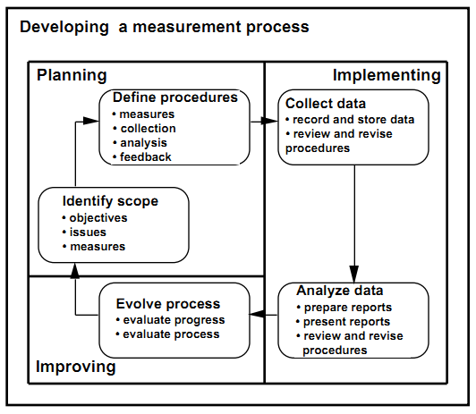
Figure 1: Software Measurement Process Architecture
The process represented in Figure 1 is analogous to the Shewhart/Deming Cycle which pertains to the fundamental tasks in quality control [Shewhart 86][Deming 86]. The Shewhart/Deming cycle has evolved and is currently described as the plan-do-check-act (PDCA) cycle. The software measurement process relates to this cycle as shown in Figure 2
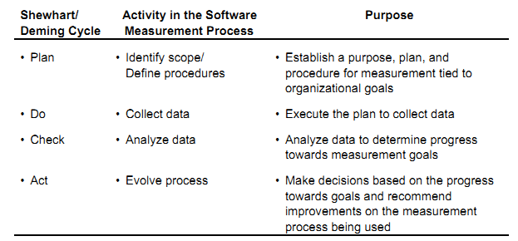
Figure 2: Relationship of the Measurement Process to PDCA

Developing a Measurement Process
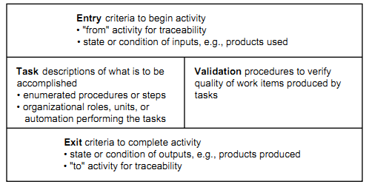
Figure 3: ETVX Diagram
The purpose of using a process definition method such as ETVX is to develop an operational definition of the measurement process. These operational definitions can then be adapted or tailored for use on all projects. To be operational, the documented process must put communicable meaning into the concepts and express the measurement process in operational terms to:
- Identify what data are to be collected,
- Define how the data are to be collected and reported,
- Define how the data are to be used to make decisions,
- Define how the process is to evolve and improve,
- Collect and analyze the data,
- Make decisions,
- Start over by continuing and/or adjusting the process.

Planning the Process
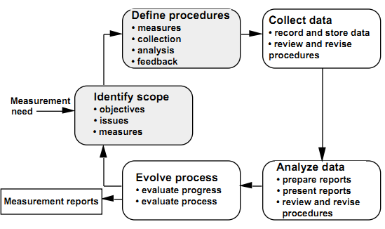
Figure 4: Measurement Architecture - Planning

Implementing the Process
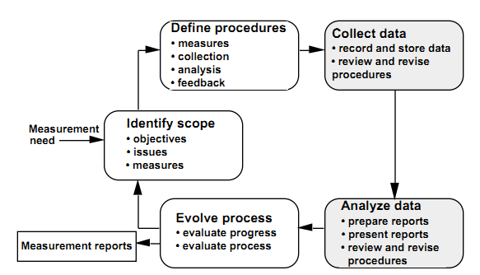
Figure 5: Measurement Architecture - Implementing

Evolving the Process
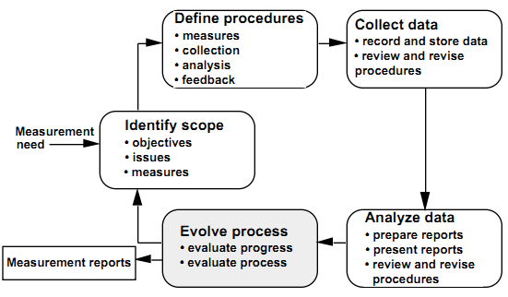
Figure 6: Measurement Architecture – Evolving

12 Steps to Useful Software Metrics
If the metric is to provide useful information, everyone involved in designing, implementing, collecting data for and utilizing a software metrics must understand its definition and purpose.
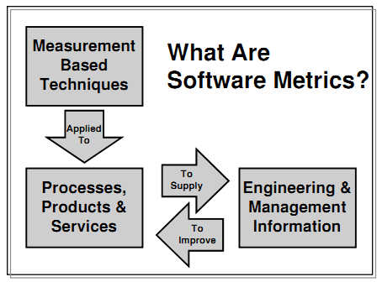

Step 1 – Identify Metrics Customers
The first step of the “12 Steps to Useful Software Metrics” is to identify the customers for each metric. The customer of the metric is the person (or people) who will be making decisions or taking action based upon the metric; the person/people who needs the information supplied by the metric. Customers may include:
Functional Management: Interested in applying greater control to the software development process, reducing risk and maximizing return on investment.
Project Management: Interested in being able to accurately predict and control project size, effort, resources, budgets and schedules. Interested in controlling the projects they are in charge of and communicating facts to their management.
Software Engineers/Programmers: The people that actually do the software development. Interested in making informed decisions about their work and work products. These people are responsible for collecting a significant amount of the data required for the metrics program.
Test Managers/Testers: The people responsible for performing the verification and validation activities. Interested in finding as many new defects as possible in the time allocated to testing and in obtaining confidence that the software works as specified. These people are also responsible for collecting a significant amount of the required data.
Specialists: Individuals performing specialized functions (e.g., Marketing, Software Quality Assurance, Process Engineering, Software Configuration Management, Audits and Assessments, Customer Technical Assistance). Interested in quantitative information upon which they can base their decisions, finding and recommendations
Customers/Users: Interested in on-time delivery of high quality software products and in reducing the over-all cost of ownership.
If a metric does not have a customer, it should not be produced. Metrics are expensive to collect, report, and analyze so if no one is using a metric, producing it is a waste of time and money.

Step 2 – Target Goals
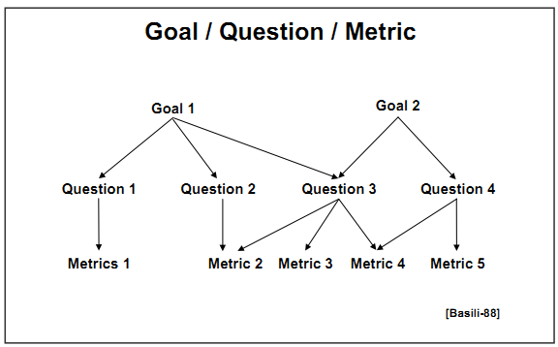
Figure 7: Goal/Question/Metric Paradigm

Step 3 – Ask Questions
The third step is to define the questions that need to be answered in order to ensure that each goal is being obtained. For example, if our goal was to ship only defect-free software, we might select the questions:
- Is the software product adequately tested?
- How many defects are still undetected?
- Are all known defects corrected?

Step 4 – Select Metrics
The fourth step is to select metrics that provide the information needed to answer these questions. Each selected metric now has a clear objective -- to answer one or more of the questions that need to be answered to determine if we are meeting our goals.
When we are selecting metrics, we must be practical, realistic, and pragmatic. Avoid the "ivory-tower" perspective that is completely removed from the existing software-engineering environment. Start with what is possible within the current process. Once we have a few successes, our customers will be open to more radical ideas -- and may even come up with a few of their own.
Also, remember software metrics don't solve problems. People solve problems. Software metrics act as indicators and provide information so people can make more informed decisions and intelligent choices.
An individual metric performs one of four functions. Metrics can help us Understand more about our software products, processes, and services. Metrics can be used to Evaluate our software products, processes, and services against established standards and goals. Metrics can provide the information we need to Control resources and processes used to produce our software. Metrics can be used to Predict attributes of software entities in the future.
A requirements statement for each metric can be formally defined in terms of one of these four functions, the attribute of the entity being measured and the goal for the measurement. This leads to the following metrics objective template:
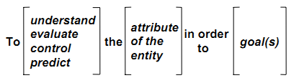
An example of the use of this template for the “percentage of known defects corrected” metric would be
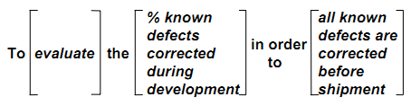
Having a clearly defined and documented requirements statement for each metric has the following benefits:
- Provides a rigor and discipline that helps ensure a well-defined metric based on customer goals
- Eliminates misunderstandings about how the metric is intended to be used
- Communicates the need for the metric, which can help in obtaining resources to implement the data collection and reporting mechanisms
- Provides the basis for the design of the metric

Step 5 – Standardize Definitions
The fifth step is to agree to standard definitions for the entities and their measured attributes. When we use terms like defect, problem report, size, and even project, other people will interpret these words in their own context with meanings that may differ from our intended definition. These interpretation differences increase when more ambiguous terms like quality, maintainability, and user-friendliness are used.
Additionally, individuals may use different terms to mean the same thing. For example, the terms defect report, problem report, incident report, fault report, or customer call report may be used by various organizations to mean the same thing, but unfortunately they may also refer to different entities. One external customer may use customer call report to refer to their complaint and problem report as the description of the defect in the software, while another customer may use problem report for the initial complaint. Differing interpretations of terminology may be one of the biggest barriers to understanding

Step 6 – Choose a Measurement Function
The sixth step is to choose a measurement function for the metric. In simple terms, the measurement function defines how we are going to calculate the metric. Some metrics, called base measures or metric primitives, are measured directly and their measurement function typically consists of a single variable.

Step 7 – Establish a Measurement Method
The seventh step in designing a metric is to break the function down into its lowest level base measures (metric primitives) and define the measurement method used to assign a value to each of those base measures. The measurement method defines the mapping system that is used to assign numbers or symbols to the attributes. The base measures and their counting criteria define the first level of data that needs to be collected in order to implement the metric.

Step 8 – Define Decision Criteria

Step 9 – Define Reporting Mechanisms
The ninth step is to decide how to report the metric. This includes defining the report format, data extraction and reporting cycle, reporting mechanisms, distribution, and availability

Step 10 – Determine Additional Qualifiers
The tenth step in designing a metric is determining the additional metric qualifiers. A good metric is a generic metric. That means the metric is valid for an entire hierarchy of additional qualifiers.

Step 11 – Collect Data
The question of "what data to collect?" was actually answered in steps 7 and 10 above. The answer is to collect all of the data required to provide the metrics primitives and the additional qualifiers.

Step 12 – The People Side of the Metrics Equation
- Don't measure individuals
- Never use metrics as a "stick"
- Don't ignore the data
- Never use only one metric
- Select metrics based on goals

